**A**

**Project Based Learning**

**Report on**

**“Weather Pal- A weather website”**

SUBMITTED TO THE SAVITRIBAI PHULE PUNE UNIVERSITY, PUNE IN

PARTIAL FULFILLMENT OF THE REQUIREMENTS FOR THE AWARD OF

**SECOND YEAR COMPUTER ENGINEERING**

**SUBMITTED BY**

**Sarah Khambatta ROLL NO – C25521**

**UNDER THE GUIDANCE OF**

**Prof. Priyanka Khalate**



**DEPARTMENT OF COMPUTER ENGINEERING**

**STES SMT. KASHIBAI NAVALE COLLEGE OF ENGINEERING,**

**VADGAON BK, PUNE – 411041**

**2023-24**

**AFFILIATED TO**



**CERTIFICATE**

This is to certify that the seminar report entities

“TITLE”

Submitted by

**Sarah Khambatta**

is a bonafide work carried out by above students under the guidance of Prof. Priyanka Khalate and it is approved for the Project Based Learning 2– Project fulfilment of the requirement of Savitribai Phule Pune University.

**Prof. P. Khalate Prof. R.H. Borhade**

**Subject Teacher HOD, Computer Engineering**

**Dr. A.V. Deshpande**

**Principal**

**STES’ S SMT. KASHIBAI NAVALE COLLEGE OF ENGINEERING,VADGAON,**

**PUNE.**

**Place: PUNE**

**Date: 08 / 04 /2024**

**ACKNOWLEDGEMENT**

With due respect and gratitude I take the opportunity to thank those who have Helped me directly and indirectly. I convey my sincere thanks to Prof.R.H.Borhade HoD computer Dept. and Prof. Priyanka Khalate for their help in selecting project topic and support. I thank my Project guide Prof.Priyanka Khalate for her guidance, timely Help and valuable suggestions without which this project would not have been. Possible. Her direction has always been encouraging as well as inspiring for me. Attempts have been made to minimize the errors in the report. I would also like to express my appreciation and thanks to all my friends who Knowingly or unknowingly have assisted and encourage me throughout my hard Work.

**ABSTRACT**

WeatherPal is a dynamic web-based platform designed to provide users with comprehensive weather information alongside essential travel details for cities worldwide. Through a user-friendly interface, WeatherPal offers real-time weather updates, detailed forecasts, and interactive maps for any specified location.

Key features of WeatherPal include:

1. **Accurate Weather Data**: WeatherPal utilizes reliable meteorological sources to deliver up-to-date weather conditions, including temperature, humidity, precipitation, wind speed, and atmospheric pressure.
2. **Customized City Search**: Users can easily search for their desired city or location, accessing precise weather forecasts tailored to their preferences.
3. **State Information**: In addition to weather updates, WeatherPal provides valuable information about the state or region where the selected city is located. This includes details such as local time zones, cultural insights, and notable attractions.
4. **Travel Guidance**: WeatherPal offers travel-related guidance to assist users in planning their trips effectively. This includes recommendations for optimal travel times based on weather conditions, transportation options, accommodation suggestions, and popular tourist destinations.
5. **Interactive Maps**: WeatherPal integrates interactive maps to visualize weather patterns, allowing users to track storms, monitor temperature variations, and explore geographical features.

WeatherPal aims to enhance user experiences by combining comprehensive weather insights with valuable travel information, empowering individuals to make informed decisions and better navigate their surroundings, whether for leisure or business purposes.

**TABLE OF CONTENTS**

* **Introduction**
* **Technical Content**
* **Future Prospect**
* **Application Design**
* **Conclusion**
* **Screenshots/ Images**
* **References**

**Introduction**

In an increasingly interconnected world where travel has become more accessible than ever, having access to reliable weather information is essential for planning safe and enjoyable journeys. Weather Pal emerges as a comprehensive solution, offering users not only real-time weather updates but also invaluable travel insights for cities across the globe.

Imagine you're planning a weekend getaway to a bustling metropolis or embarking on a cross-country adventure. You want to ensure your trip goes smoothly, from packing the right attire to choosing the best time to explore local attractions. This is where Weather Pal steps in, serving as your trusted companion in navigating both the atmospheric and geographical landscapes of your destination.

With Weather Pal, you're not just receiving basic weather forecasts; you're gaining access to a wealth of information tailored to your needs. Whether you're a seasoned traveler seeking adventure or a business professional planning a crucial trip, Weather Pal caters to your requirements with precision and convenience.

Through an intuitive interface, users can effortlessly search for any city worldwide and receive detailed weather updates, including temperature variations, precipitation forecasts, wind speeds, and more. But Weather Pal goes beyond the basics. It provides context by offering insights into the state or region where the chosen city resides, enriching your understanding of the local culture, traditions, and attractions.

Moreover, Weather Pal doesn't stop at providing weather and state information. It recognizes that seamless travel planning involves considering various factors, such as transportation options, accommodation availability, and ideal times to visit. With this in mind, Weather Pal offers invaluable travel guidance, helping users make informed decisions every step of the way.

Whether you're a leisure traveler seeking the perfect beach destination or a business traveler navigating unfamiliar territories, Weather Pal ensures you're equipped with the knowledge needed to make the most of your journey. So, embark on your next adventure with confidence, armed with the power of Weather Pal by your side.

**Technical Content**

WeatherPal is a full-stack web development project that incorporates various technologies to deliver a seamless user experience in accessing weather information and travel guidance. The project encompasses front-end development, back-end functionality, and integration with external APIs to provide accurate and comprehensive data to users.

1. **Front-End Development**:
   * WeatherPal's user interface (UI) is developed using HTML, CSS, and JavaScript, ensuring a visually appealing and responsive design across different devices and screen sizes.
   * The front-end utilizes modern frameworks such as React.js or AngularJS to create dynamic, interactive components for users to input city names, view weather forecasts, and explore travel information.
2. **Back-End Development**:
   * WeatherPal's back-end is built using server-side languages like Node.js, Python, or Java, along with frameworks such as Express.js or Flask, to handle user requests, process data, and interact with databases.
   * The back-end communicates with external APIs, such as weather APIs (e.g., OpenWeatherMap API, Weatherstack API) to fetch real-time weather data for specified cities, and location APIs (e.g., Google Maps API) to obtain geographic information and travel-related data.
3. **Database Management**:
   * WeatherPal employs a database management system (DBMS) like MySQL, PostgreSQL, or MongoDB to store user preferences, historical weather data, and other relevant information.
   * The database architecture is designed to efficiently store and retrieve data, ensuring fast response times and seamless user interactions.
4. **API Integration**:
   * WeatherPal integrates with various third-party APIs to enhance its functionality. For weather data, it utilizes APIs that provide current conditions, forecasts, and historical weather information for cities worldwide.
   * Additionally, WeatherPal leverages location-based APIs to gather data on states, time zones, nearby attractions, and travel recommendations, enriching the user experience with contextual information.
5. **Security Measures**:
   * WeatherPal implements security best practices to protect user data and prevent unauthorized access. This includes encryption techniques for sensitive information, such as user credentials and session management, as well as measures to prevent common web vulnerabilities like Cross-Site Scripting (XSS) and Cross-Site Request Forgery (CSRF).
6. **Deployment and Scalability**:
   * WeatherPal is deployed on a scalable hosting platform such as AWS (Amazon Web Services), Microsoft Azure, or Google Cloud Platform, ensuring high availability and efficient resource management.
   * Continuous integration and deployment (CI/CD) pipelines are employed to automate the deployment process, facilitating rapid updates and enhancements to the WeatherPal platform.

Overall, WeatherPal demonstrates the integration of front-end and back-end technologies, coupled with API integration and database management, to deliver a robust and feature-rich web application for accessing weather information and travel guidance.

Top of Form

Here's a more detailed breakdown of the technologies comprising the tech stack for WeatherPal:

1. **Front-End Development**:
   * **HTML, CSS, JavaScript**: These fundamental web technologies are used to structure the website's layout, style its elements, and add interactivity.
   * **React.js or Angular**: These popular JavaScript frameworks are utilized for building dynamic and responsive user interfaces. They enable the creation of reusable components, state management, and efficient rendering of UI elements.
2. **Back-End Development**:
   * **Node.js with Express.js or Python with Flask/Django or Java with Spring Boot**: These server-side frameworks provide the foundation for handling HTTP requests, routing, middleware integration, and overall server logic. Node.js offers a non-blocking, event-driven architecture, while Python and Java provide robustness and scalability.
   * **RESTful APIs**: RESTful architecture is commonly used to design APIs for communication between the front-end and back-end components. It defines clear endpoints and methods for accessing resources, facilitating data exchange in a stateless manner.
3. **Database Management**:
   * **MySQL, PostgreSQL, MongoDB**: These are popular choices for relational and NoSQL databases, respectively. They are used for storing user data, preferences, historical weather information, and other relevant datasets. Relational databases like MySQL and PostgreSQL offer structured data storage and support complex queries, while MongoDB provides flexibility for handling unstructured or semi-structured data.
4. **API Integration**:
   * **Weather APIs (e.g., OpenWeatherMap API, Weatherstack API)**: These APIs provide real-time weather data, forecasts, and historical weather information for specific locations. They are integrated into WeatherPal to fetch weather updates based on user inputted city names.
   * **Location APIs (e.g., Google Maps API)**: Location-based APIs offer geographical information, including state details, time zones, nearby attractions, and travel recommendations. They enhance WeatherPal's functionality by providing contextual data relevant to users' selected locations.
5. **Security Measures**:
   * **Encryption**: Techniques like HTTPS encryption are employed to secure data transmission between the client and server, safeguarding sensitive information such as user credentials and session tokens.
   * **Authentication and Authorization**: User authentication mechanisms, such as JSON Web Tokens (JWT) or OAuth, are implemented to verify user identities and control access to protected resources. Role-based access control (RBAC) may be utilized for fine-grained authorization.
   * **Input Validation and Sanitization**: Measures are taken to validate and sanitize user input to prevent common web vulnerabilities such as SQL injection, Cross-Site Scripting (XSS), and Cross-Site Request Forgery (CSRF).
6. **Deployment and Scalability**:
   * **Cloud Hosting Platforms (e.g., AWS, Azure, Google Cloud Platform)**: WeatherPal is deployed on scalable cloud infrastructure to ensure high availability, reliability, and efficient resource management. Cloud services like AWS Elastic Beanstalk or Google App Engine facilitate deployment and auto-scaling based on demand.
   * **Continuous Integration/Continuous Deployment (CI/CD)**: CI/CD pipelines automate the build, testing, and deployment processes, enabling rapid iteration and deployment of new features and updates to the WeatherPal platform.

By leveraging this comprehensive tech stack, WeatherPal delivers a robust, scalable, and feature-rich web application for accessing weather information and travel guidance, catering to the diverse needs of its users.

Top of Form

**Future Prospects**

1. **Enhanced User Experience**: WeatherPal can continually improve its user interface and experience by incorporating user feedback, conducting usability testing, and implementing new features to streamline navigation and access to weather and travel information.
2. **Integration of AI and Machine Learning**: By leveraging AI and machine learning algorithms, WeatherPal can enhance its predictive capabilities, providing users with more accurate and personalized weather forecasts. AI can also be utilized to analyze user preferences and behavior, offering tailored travel recommendations and suggestions.
3. **Expansion of Geographic Coverage**: WeatherPal can expand its coverage to include more cities, regions, and countries worldwide, catering to the needs of travelers and weather enthusiasts globally. This expansion may involve partnerships with local weather agencies and organizations to access reliable data sources.
4. **Mobile Application Development**: Developing a mobile application for WeatherPal can significantly increase its accessibility and reach, allowing users to access weather and travel information on-the-go. The app can leverage device features such as GPS for location-based services and push notifications for weather alerts and updates.
5. **Monetization Strategies**: WeatherPal can explore various monetization strategies, such as premium subscription services, targeted advertising, affiliate partnerships with travel-related businesses, and sponsored content collaborations. These strategies can generate revenue while providing added value to users.
6. **Community Engagement and Social Features**: WeatherPal can foster a sense of community among users by incorporating social features such as user-generated content, forums, and discussion boards. Users can share travel experiences, tips, and recommendations, enriching the platform with valuable insights and fostering user engagement.
7. **Partnerships and Collaborations**: Collaborating with travel agencies, airlines, hotels, and other travel-related businesses can create synergies and opportunities for cross-promotion and co-marketing initiatives. Strategic partnerships can also enable WeatherPal to access exclusive deals and discounts for its users.
8. **Environmental Sustainability Initiatives**: WeatherPal can incorporate environmental sustainability initiatives by providing information on eco-friendly travel options, carbon footprint calculations, and tips for reducing environmental impact while traveling. Promoting sustainable tourism practices aligns with growing consumer preferences for eco-conscious travel.

Overall, the future of WeatherPal is bright, with potential for innovation, growth, and continued relevance in the dynamic landscape of weather forecasting and travel planning. By staying agile, responsive to user needs, and abreast of technological advancements, WeatherPal can solidify its position as a leading destination for weather enthusiasts and travelers alike.

Top of Form

**Application Design**

Designing the application architecture and user interface for WeatherPal involves several key components and considerations to ensure a seamless and intuitive user experience. Here's a detailed breakdown of the application design:

1. **User Interface Design**:
   * **Homepage**: The homepage serves as the entry point for users and typically features a search bar where users can input the name of the city they want to check the weather for. It may also include featured destinations, weather highlights, and quick access to popular cities.
   * **Weather Dashboard**: After entering a city name, users are directed to the weather dashboard, which displays current weather conditions, temperature, humidity, wind speed, and other relevant metrics. It may also include graphical representations such as icons for weather conditions and charts for temperature trends.
   * **Navigation Menu**: A navigation menu allows users to explore different sections of the application, such as viewing weather forecasts for upcoming days, accessing travel information, saving favorite cities, and adjusting settings.
   * **Travel Information Section**: This section provides users with valuable travel-related data, including state information, time zone details, local attractions, transportation options, and accommodation suggestions. It may also include user reviews, ratings, and photos of popular destinations.
   * **Interactive Maps**: Interactive maps allow users to visualize weather patterns, explore geographic features, and find nearby points of interest. Users can toggle layers for weather overlays, satellite imagery, and terrain views to gain deeper insights into their chosen location.
   * **Settings and Preferences**: Users can customize their experience by adjusting settings such as temperature units (Celsius or Fahrenheit), language preferences, notification preferences, and account settings.
2. **Application Architecture**:
   * **Client-Server Architecture**: WeatherPal follows a client-server architecture, where the client (web browser or mobile app) sends requests to the server (back-end) to retrieve weather and travel data. The server processes these requests, interacts with external APIs, and sends back responses to the client.
   * **Front-End Components**: The front-end of WeatherPal is developed using HTML, CSS, and JavaScript frameworks such as React.js or Angular. It consists of various components responsible for rendering the user interface, handling user interactions, and making requests to the back-end.
   * **Back-End Components**: The back-end of WeatherPal is built using server-side technologies such as Node.js with Express.js, Python with Flask/Django, or Java with Spring Boot. It includes modules for routing, handling API requests, interacting with the database, and implementing business logic.
   * **Database Management**: WeatherPal utilizes a database management system (DBMS) such as MySQL, PostgreSQL, or MongoDB to store user data, weather information, travel details, and other relevant datasets. The database is structured to efficiently store and retrieve data, ensuring fast response times.
   * **API Integration**: WeatherPal integrates with external APIs such as weather APIs (e.g., OpenWeatherMap API, Weatherstack API) and location APIs (e.g., Google Maps API) to fetch real-time weather data, geographic information, and travel recommendations. These APIs provide the data needed to populate the application's features and functionalities.
3. **Security and Performance Considerations**:
   * **Security**: WeatherPal implements security measures such as HTTPS encryption, user authentication, input validation, and protection against common web vulnerabilities (e.g., XSS, CSRF). It follows best practices for securing sensitive user data and preventing unauthorized access.
   * **Performance**: WeatherPal optimizes performance by minimizing page load times, caching frequently accessed data, and leveraging techniques such as lazy loading and code splitting to improve rendering speed. It also implements server-side and client-side caching to reduce the load on the server and enhance scalability.
4. **Scalability and Deployment**:
   * **Scalability**: WeatherPal is designed to be scalable, allowing it to handle increasing numbers of users and traffic. It utilizes cloud hosting platforms such as AWS, Azure, or Google Cloud Platform, which offer auto-scaling capabilities and on-demand resource allocation.
   * **Deployment**: WeatherPal employs continuous integration/continuous deployment (CI/CD) pipelines to automate the deployment process, ensuring rapid and reliable releases of new features and updates. It follows deployment best practices to minimize downtime and maintain application availability.

By incorporating these design principles and considerations, WeatherPal delivers a user-friendly, reliable, and feature-rich application for accessing weather information and travel guidance, catering to the diverse needs of its users.

Top of Form

**Conclusion**

In conclusion, WeatherPal stands as a robust and user-centric web application, seamlessly integrating weather information and travel guidance to empower users in their journey planning endeavors. Through meticulous design and implementation, WeatherPal offers a comprehensive platform that caters to the diverse needs of weather enthusiasts, travelers, and adventure seekers alike.

From its intuitive user interface to its sophisticated backend architecture, WeatherPal prioritizes usability, performance, and security. The application's frontend, developed with modern technologies such as React.js or Angular, provides a visually appealing and responsive experience, ensuring accessibility across devices. Meanwhile, the backend, powered by Node.js, Python, or Java frameworks, handles data processing, API integration, and business logic with efficiency and reliability.

By leveraging external APIs for weather data and location-based services, WeatherPal delivers accurate and up-to-date information, empowering users to make informed decisions about their travel plans. From real-time weather updates to detailed travel recommendations and interactive maps, WeatherPal equips users with the tools they need to navigate their destinations confidently.

Looking ahead, WeatherPal's future prospects are promising. Opportunities for growth and innovation abound, whether through the integration of AI and machine learning for predictive analytics, the expansion of geographic coverage to include more cities and regions worldwide, or the development of a mobile application for on-the-go access.

Ultimately, WeatherPal's commitment to enhancing user experiences, fostering community engagement, and promoting sustainable travel practices positions it as a leading destination for weather enthusiasts and travelers seeking adventure, exploration, and discovery. With continued dedication to excellence and responsiveness to user feedback, WeatherPal is poised to thrive in the dynamic landscape of weather forecasting and travel planning for years to come.

Top of Form

**Screenshots/ Images**

**The following images contain various cities and their weather, temperature, windspeed, longitude and latitude; followed by the basic information of famous travel cities of India.**

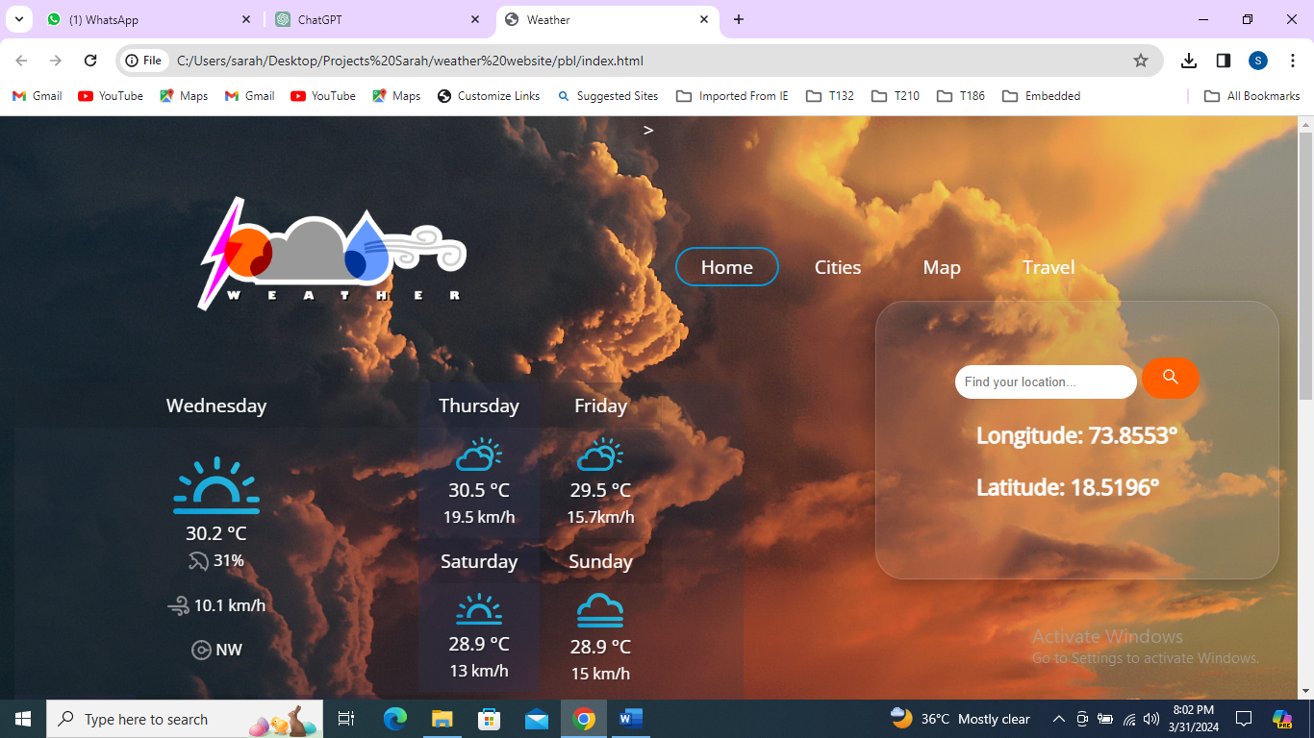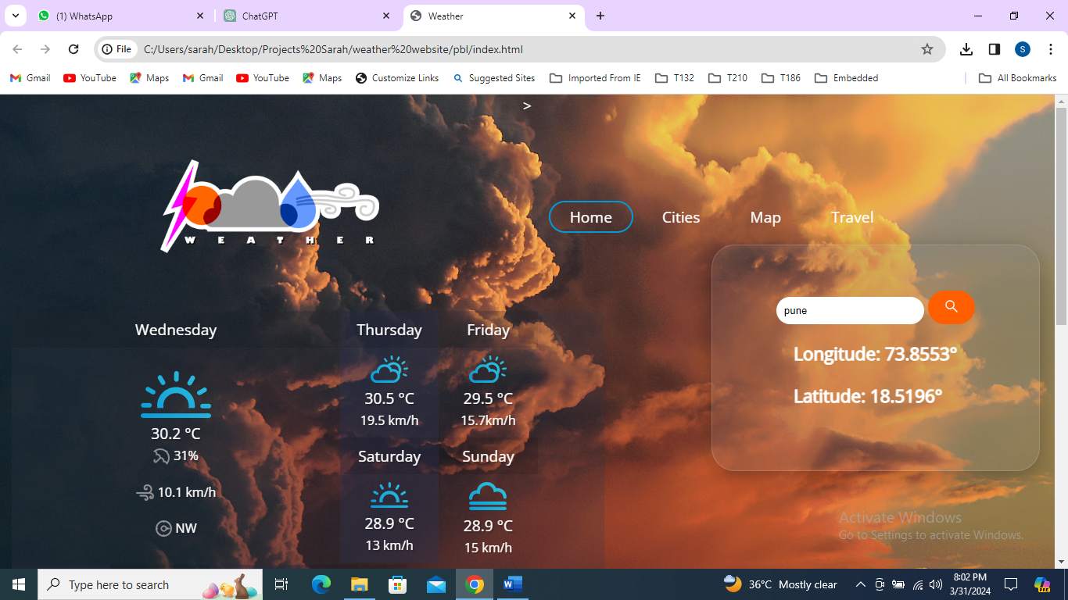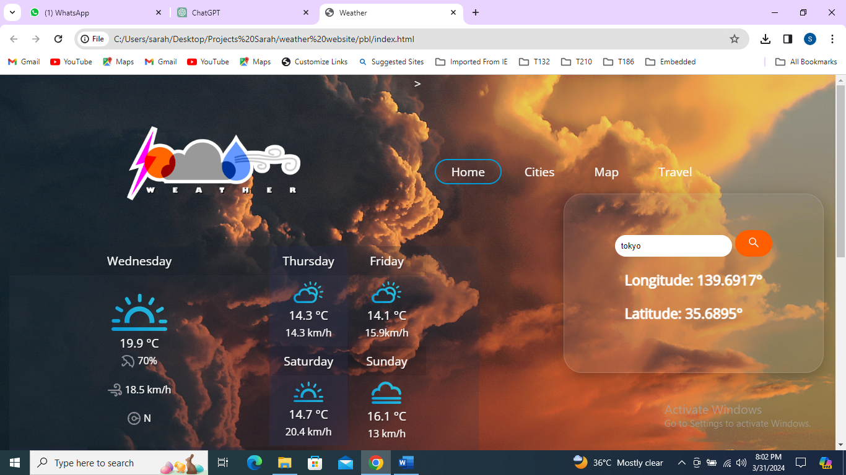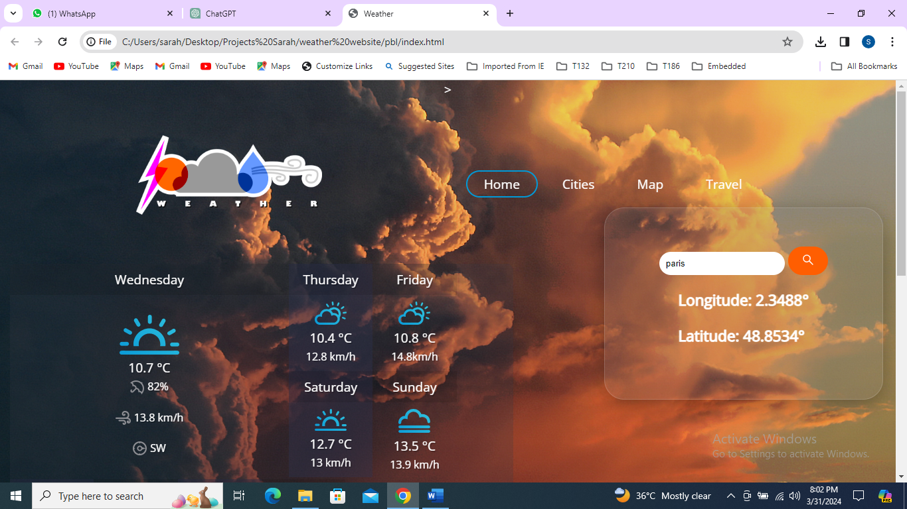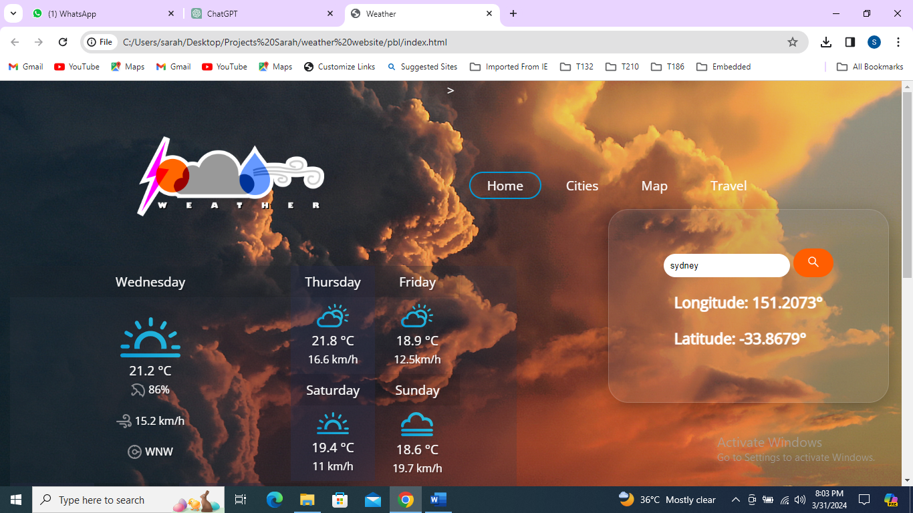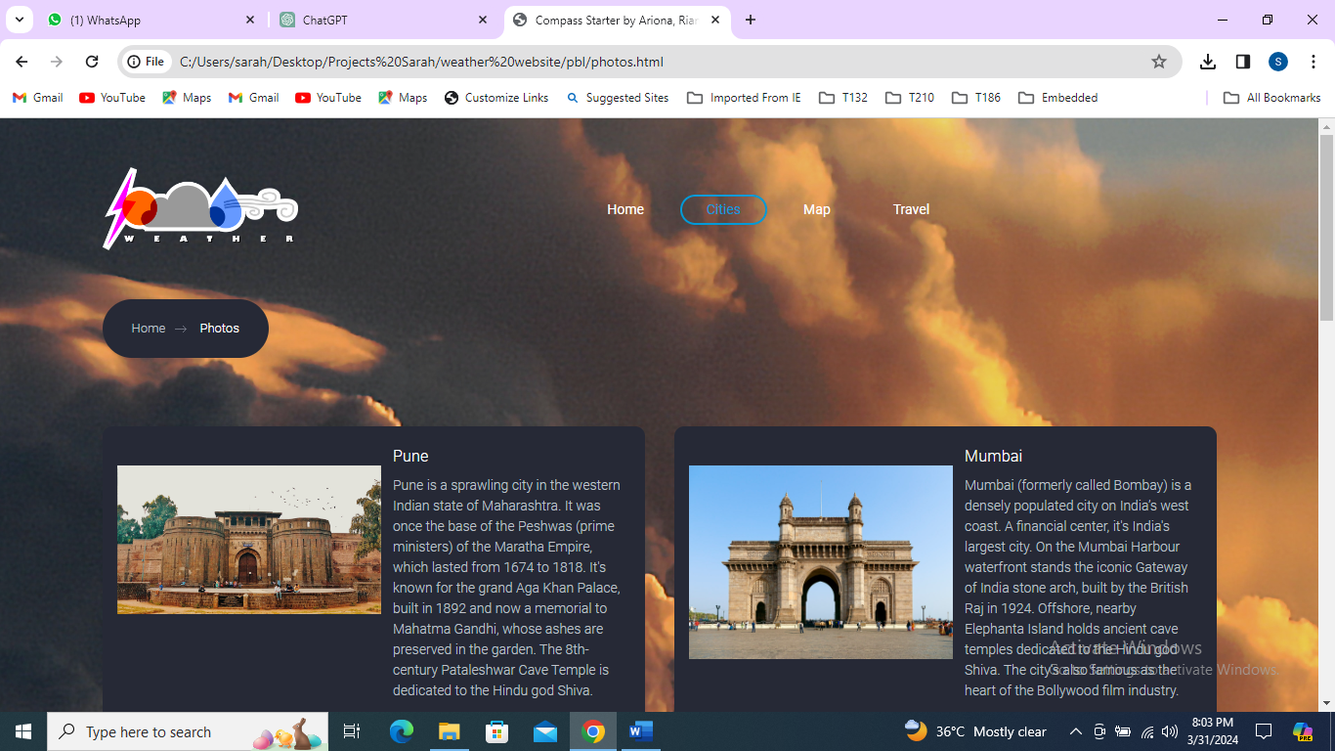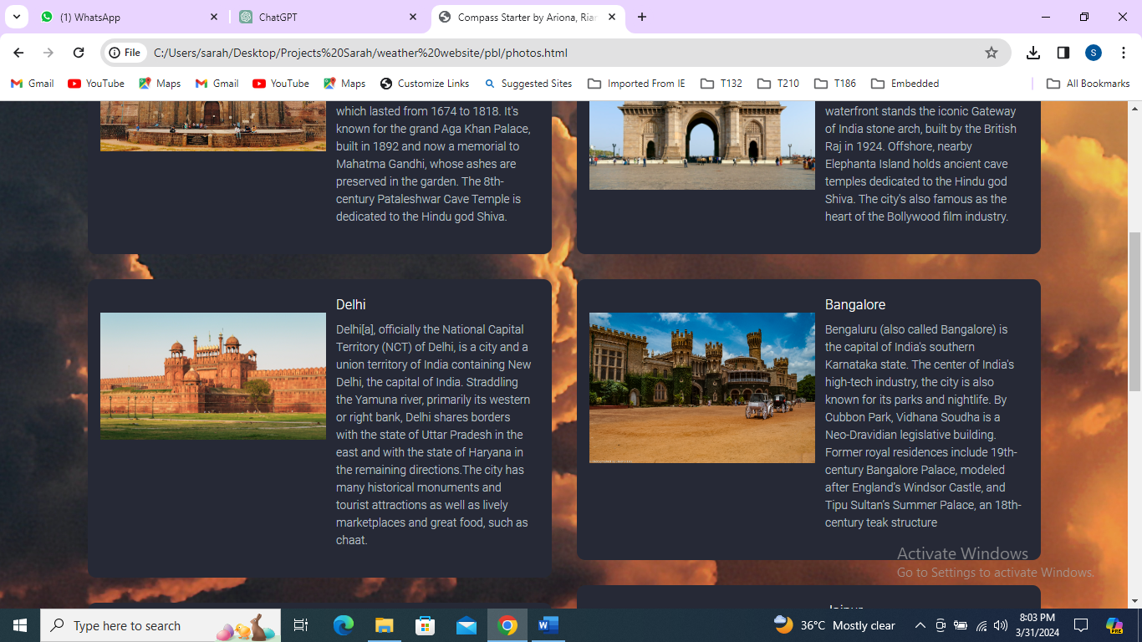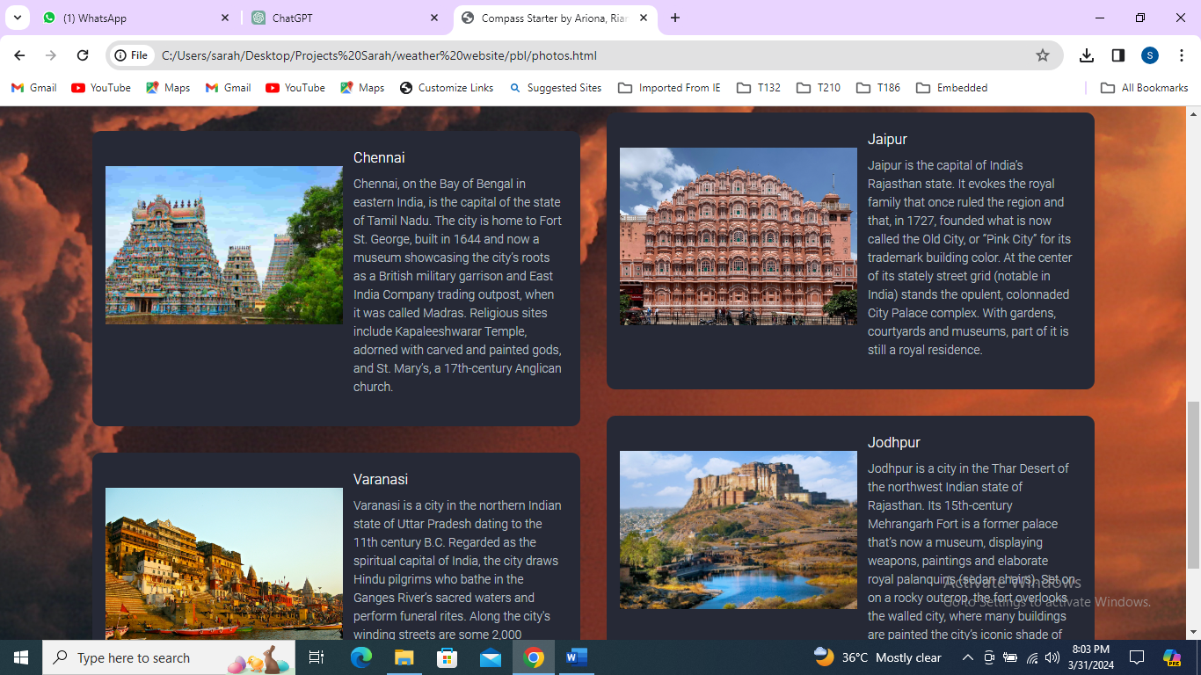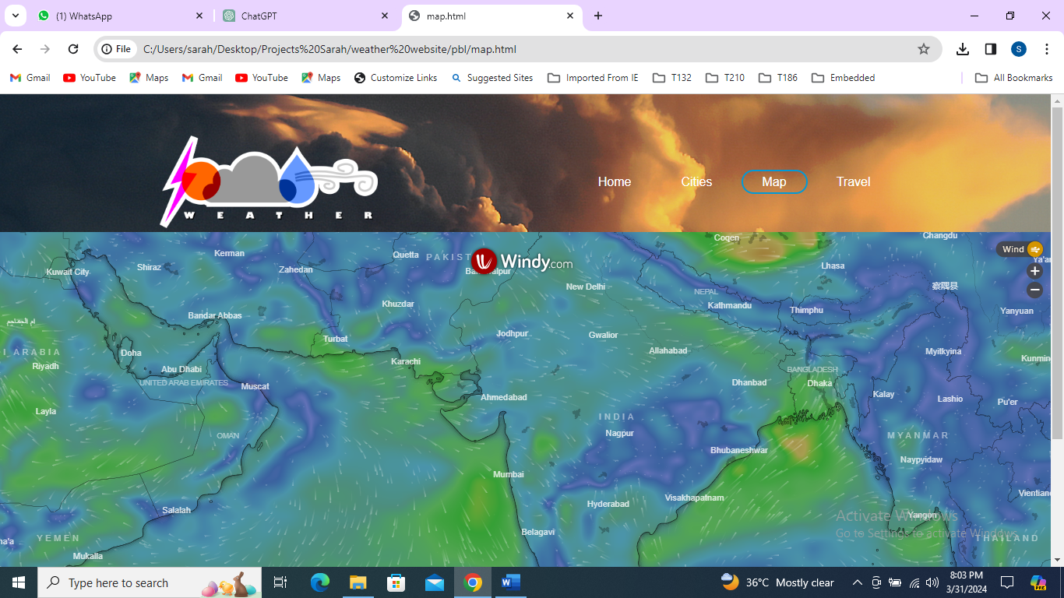

**This website shows map of winds**

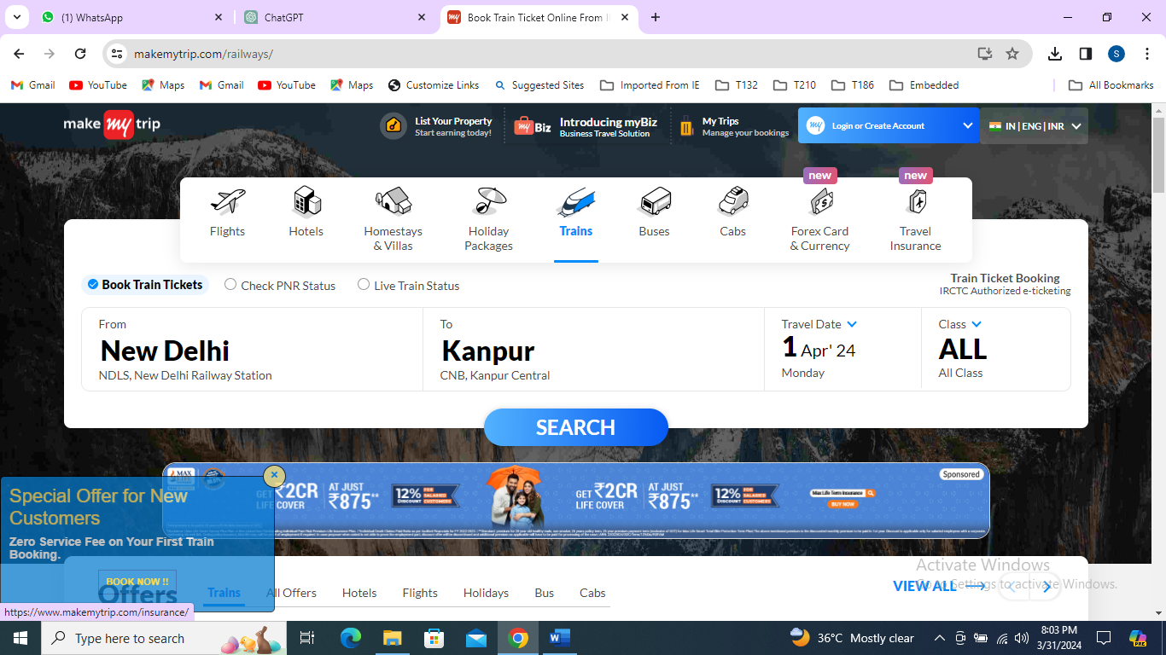

**This image shows travel website page**

**References**

1. Weather API Documentation: References to the documentation of weather APIs used in the project, such as OpenWeatherMap API, Weatherstack API, or any other weather data provider.
2. Location API Documentation: Documentation for location-based APIs like Google Maps API or Mapbox API, which provide geographical information and mapping services.
3. Front-End Framework Documentation: Documentation for front-end frameworks like React.js, Angular, or Vue.js, which provide guidance on building interactive user interfaces.
4. Back-End Framework Documentation: Documentation for back-end frameworks like Node.js with Express.js, Python with Flask/Django, or Java with Spring Boot, which provide guidance on server-side development.
5. Database Documentation: Documentation for the database management system used in the project, such as MySQL, PostgreSQL, or MongoDB, which provides guidance on data modeling, querying, and management.
6. Web Development Best Practices: References to articles, books, or online courses on web development best practices, including topics like security, performance optimization, and scalability.
7. CI/CD Documentation: Documentation for tools and services used for continuous integration and continuous deployment (CI/CD), such as Jenkins, Travis CI, or GitHub Actions.
8. Cloud Hosting Platform Documentation: Documentation for cloud hosting platforms like AWS (Amazon Web Services), Microsoft Azure, or Google Cloud Platform, which provide guidance on deploying and scaling web applications in the cloud.

These references can serve as a starting point for further exploration and research into the technologies and methodologies used in the WeatherPal project.

Top of Form

1. **Weather API Documentation**:
   * OpenWeatherMap API: OpenWeatherMap API Documentation
   * Weatherstack API: Weatherstack API Documentation
2. **Location API Documentation**:
   * Google Maps Platform: [Google Maps Platform Documentation](https://developers.google.com/maps/documentation)
3. **Front-End Framework Documentation**:
   * React.js: React Documentation
   * Angular: Angular Documentation
   * Vue.js: Vue.js Documentation
4. **Back-End Framework Documentation**:
   * Express.js: [Express.js Documentation](https://expressjs.com/)
   * Flask: Flask Documentation
   * Django: [Django Documentation](https://docs.djangoproject.com/en/stable/)
5. **Database Documentation**:
   * MySQL: [MySQL Documentation](https://dev.mysql.com/doc/)
   * PostgreSQL: [PostgreSQL Documentation](https://www.postgresql.org/docs/)
   * MongoDB: [MongoDB Documentation](https://docs.mongodb.com/)
6. **Web Development Best Practices**:
   * Various articles and tutorials can be found on websites like Medium, Smashing Magazine, and freeCodeCamp.
   * Books such as "Clean Code" by Robert C. Martin and "High-Performance Browser Networking" by Ilya Grigorik offer insights into best practices.
7. **CI/CD Documentation**:
   * Jenkins: Jenkins Documentation
   * Travis CI: Travis CI Documentation
   * GitHub Actions: [GitHub Actions Documentation](https://docs.github.com/en/actions)
8. **Cloud Hosting Platform Documentation**:
   * AWS (Amazon Web Services): [AWS Documentation](https://docs.aws.amazon.com/)
   * Microsoft Azure: [Azure Documentation](https://docs.microsoft.com/en-us/azure/)
   * Google Cloud Platform: [Google Cloud Documentation](https://cloud.google.com/docs)